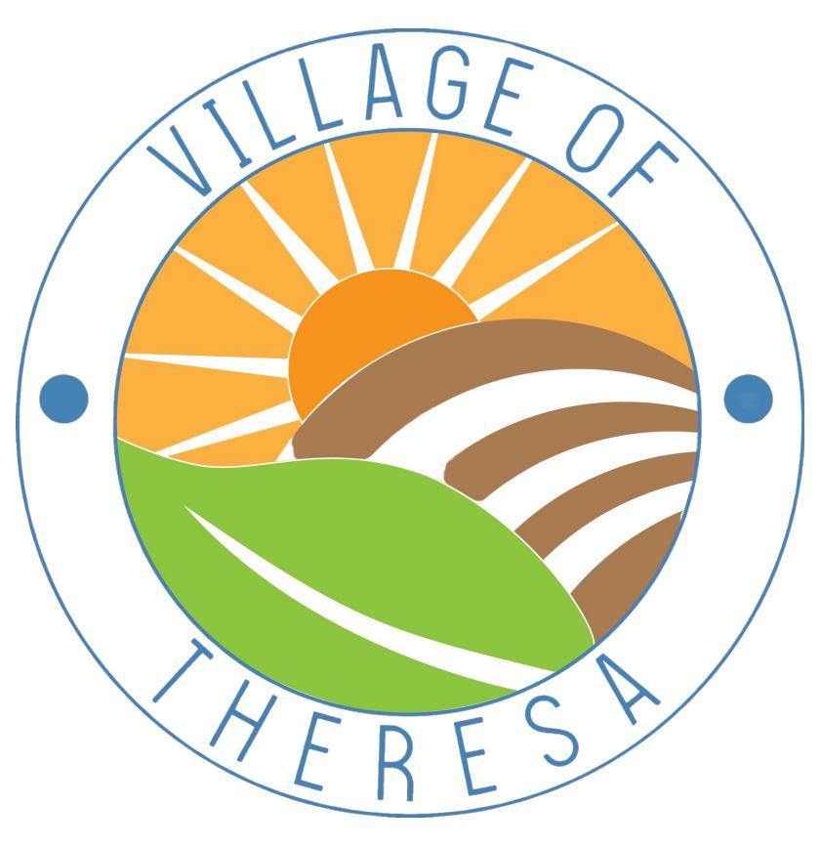
Year-End Reminders for Residents
(Friendly reminders to help wrap up the year smoothly!)
📍 292 Mayville Street, Theresa, WI 53091 ☎️ (920) 488-5421
🌐 https://villageoftheresa.com/

🏡 Property Tax Payments  - Due Date: Full payment or first installment must be received or postmarked by January 31.  - Payment Options:  - Checks payable to: Village of Theresa, 292 Mayville Street, Theresa, WI 53091  - Use the drop box at the Village Hall (checked daily)  - Online Payment Using Theresa Community Connect  Receipts mailed only if requested—include a self-addressed stamped envelope. | 🐾 Dog Licensing – Due by March 31  - All dogs over 5 months old must be licensed annually  - Bring or email proof of current rabies vaccination to deputy@villageoftheresawi.gov  - Fees: $10 spayed/neutered | $15 unaltered  - Late fee: $25 per dog after March 31  - No form needed if the information appears on the rabies vaccination sheet (Dog Name, Male/Female, Breed, Color, Spayed/Neutered, Owner Physical Address & Owner Contact Info)
❄️ Snow & Ice Removal  - Property owners must clear sidewalks within 24 hours after snowfall  - Do not blow or plow snow into streets—it’s prohibited by ordinance  - Keep hydrants and storm drains clear for safety | 🚗 Winter Parking Restrictions  - No on-street parking from 2:00 AM – 6:00 AM, November 15 – April 1.  - Violations may result in tickets or towing.  - Thank you for helping our plow crews keep Theresa safe and clear!
♻️ Garbage & Recycling Schedule  - Regular collection continues on Tuesdays, unless delayed by holidays. (2026 Schedule on back)  - If a holiday falls on or before your service day, collection moves to the next day.  - Please have carts curbside by 6:00 AM and ensure lids are closed.  - Residential Bulk Waste pickup will be Tuesday, October 13, 2025 | 🕓 Village Hall Hours  - Monday – Friday: 8:00 AM – 4:00 PM  - Any change in schedule will be posted on the Village Hall door  - Closed on holidays  - Deputy Clerk-Treasurer, Kelly Brown, deputy@villageoftheresawi.gov  - Clerk-Treasurer, Becky Tellier, ct@villageoftheresawi.gov
💧 Utility Bill Reminders  - Monthly bills are sent at month-end and due on the 20th of next month.  - Payments accepted online, in-person, by mail, or via drop box at Village Hall.  • Check water usage through EyeOnWater-download the app  Reminder: We have closed PO Box 327 – our mailing  and physical address are 292 Mayville Street | Thank you for helping keep the Village of Theresa safe, clean, and beautiful!  Stay connected at https://villageoftheresawi.gov
